Query Languages

📌 Definition:
# Source: AI Source: Provided by: [Data Path: Persons Table -> ID Column: 1, Name_En Column: Motasem Essam] -> From: [ChatGPT] on [12/9/2025]
Query languages are DSLs used to retrieve, manipulate, and manage data from databases or data sources.

🧩 Common Examples:

🗄️ SQL (Structured Query Language)
# Source: AI Source: Provided by: [Data Path: Persons Table -> ID Column: 1, Name_En Column: Motasem Essam] -> From: [ChatGPT] on [12/9/2025]
- Used with relational databases
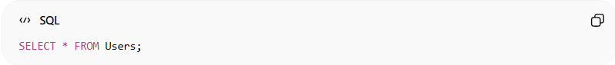
SELECT * FROM Users;

🔍 XPath
# Source: AI Source: Provided by: [Data Path: Persons Table -> ID Column: 1, Name_En Column: Motasem Essam] -> From: [ChatGPT] on [12/9/2025]
- Used to query XML documents
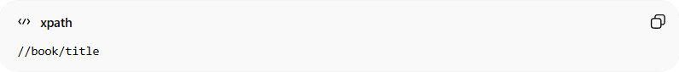
//book/title

🌐 GraphQL
# Source: AI Source: Provided by: [Data Path: Persons Table -> ID Column: 1, Name_En Column: Motasem Essam] -> From: [ChatGPT] on [12/9/2025]
- Used to query APIs (especially web services)
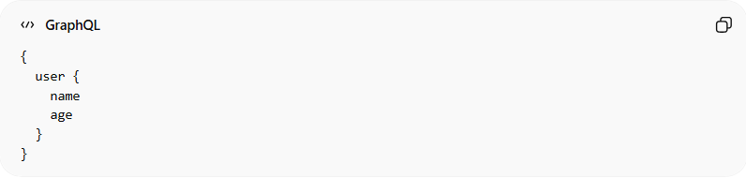
{
user {
name
age
}
}

🧾 LINQ (Language Integrated Query)
# Source: AI Source: Provided by: [Data Path: Persons Table -> ID Column: 1, Name_En Column: Motasem Essam] -> From: [ChatGPT] on [12/9/2025]
- Used in languages like C# to query data
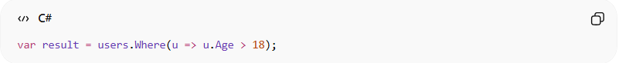
var result = users.Where(u => u.Age > 18);

⚙️ What they all do:
# Source: AI Source: Provided by: [Data Path: Persons Table -> ID Column: 1, Name_En Column: Motasem Essam] -> From: [ChatGPT] on [12/9/2025]
- Ask questions about data ❓
- Filter results 🔍
- Retrieve specific information 📊

🆚 Key idea:
# Source: AI Source: Provided by: [Data Path: Persons Table -> ID Column: 1, Name_En Column: Motasem Essam] -> From: [ChatGPT] on [12/9/2025]
All these are:
- ✅ DSLs (Domain-Specific Languages)
- 🎯 Focused on data querying only

🎯 Summary:
# Source: AI Source: Provided by: [Data Path: Persons Table -> ID Column: 1, Name_En Column: Motasem Essam] -> From: [ChatGPT] on [12/9/2025]
Query languages are DSLs designed specifically to interact with and extract data efficiently from different types of data sources.

